**PART B: CREATING A GRAPH DATABASE REPORT**

In this section, we will outline the steps taken to create and populate a Neo4j database based on the provided Formula 1 data model. Additionally, we will provide the Cypher queries devised and executed to retrieve specific information from the database.

**B1. Creating the Database**

For this task, we utilized the Neo4j Sandbox to create a database named "Rcw1PartB." We followed the given data model to create nodes and edges representing the 2023 Monaco Grand Prix, 10 teams, 20 drivers, and their finishing positions and points.

The following Cypher statements were used to create nodes and edges:

1. Create the Monaco Grand Prix and its Track:

CREATE (:Race {name: "2023 Monaco Grand Prix", date: "2023-05-28"})-[:Held_at]->(:Track {name: "Monte Carlo"})

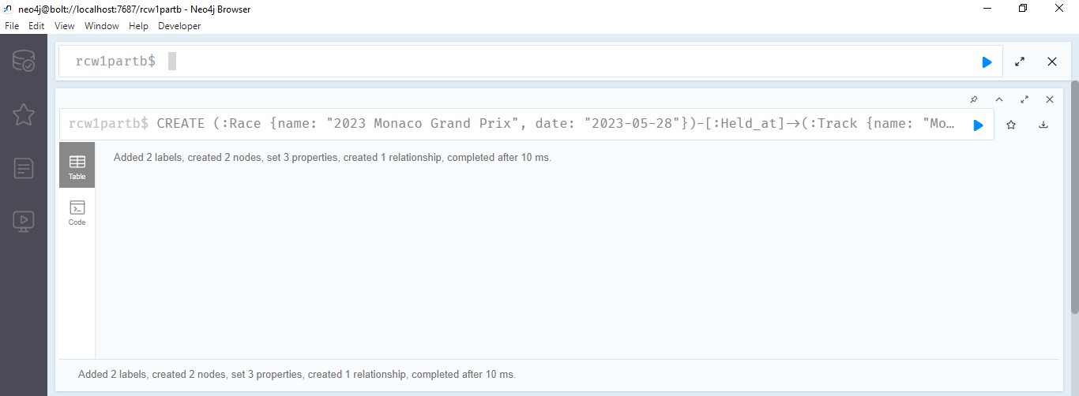

1. Create Teams and Drivers:

// Create Teams

CREATE (:Team {name: "Red Bull"})

CREATE (:Team {name: "Aston Martin"})

CREATE (:Team {name: "Alpine"})

CREATE (:Team {name: "Mercedes"})

CREATE (:Team {name: "Ferrari"})

CREATE (:Team {name: "McLaren"})

CREATE (:Team {name: "Alfa Romeo"})

CREATE (:Team {name: "AlphaTauri"})

CREATE (:Team {name: "Williams"})

CREATE (:Team {name: "Haas"})

// Create Drivers and their relationship to Teams

CREATE (:Driver {name: "Max Verstappen", number: 1})-[:Drives_for]->(:Team {name: "Red Bull"})

CREATE (:Driver {name: "Fernando Alonso", number: 14})-[:Drives_for]->(:Team {name: "Aston Martin"})

CREATE (:Driver {name: "Esteban Ocon", number: 31})-[:Drives_for]->(:Team {name: "Alpine"})

CREATE (:Driver {name: "Lewis Hamilton", number: 44})-[:Drives_for]->(:Team {name: "Mercedes"})

CREATE (:Driver {name: "George Russell", number: 63})-[:Drives_for]->(:Team {name: "Mercedes"})

CREATE (:Driver {name: "Charles Leclerc", number: 16})-[:Drives_for]->(:Team {name: "Ferrari"})

CREATE (:Driver {name: "Pierre Gasly", number: 10})-[:Drives_for]->(:Team {name: "Alpine"})

CREATE (:Driver {name: "Carlos Sainz Jnr", number: 55})-[:Drives_for]->(:Team {name: "Ferrari"})

CREATE (:Driver {name: "Lando Norris", number: 4})-[:Drives_for]->(:Team {name: "McLaren"})

CREATE (:Driver {name: "Oscar Piastri", number: 81})-[:Drives_for]->(:Team {name: "McLaren"})

CREATE (:Driver {name: "Valtteri Bottas", number: 77})-[:Drives_for]->(:Team {name: "Alfa Romeo"})

CREATE (:Driver {name: "Nyck de Vries", number: 21})-[:Drives_for]->(:Team {name: "AlphaTauri"})

CREATE (:Driver {name: "Zhou Guanyu", number: 24})-[:Drives_for]->(:Team {name: "Alfa Romeo"})

CREATE (:Driver {name: "Alexander Albon", number: 23})-[:Drives_for]->(:Team {name: "Williams"})

CREATE (:Driver {name: "Yuki Tsunoda", number: 22})-[:Drives_for]->(:Team {name: "AlphaTauri"})

CREATE (:Driver {name: "Sergio Perez", number: 11})-[:Drives_for]->(:Team {name: "Red Bull"})

CREATE (:Driver {name: "Nico Hulkenberg", number: 27})-[:Drives_for]->(:Team {name: "Haas"})

CREATE (:Driver {name: "Logan Sargeant", number: 2})-[:Drives_for]->(:Team {name: "Williams"})

CREATE (:Driver {name: "Kevin Magnussen", number: 20})-[:Drives_for]->(:Team {name: "Haas"})

CREATE (:Driver {name: "Lance Stroll", number: 18})-[:Drives_for]->(:Team {name: "Aston Martin"})

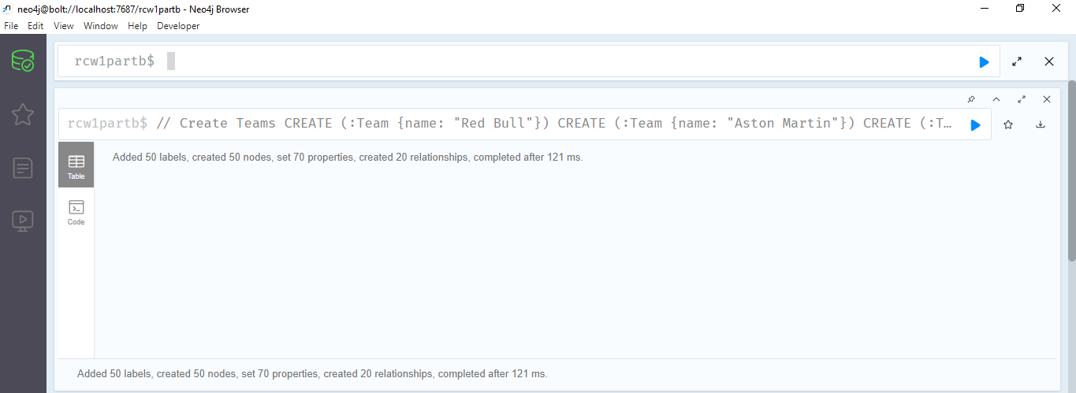

1. Populate Finishing Positions and Points:

// Create Drivers and their relationship to Race

// Create Drivers and their relationship to Race

MATCH (race:Race {name: "2023 Monaco Grand Prix"})

// Driver 1

CREATE (:Driver {name: "Max Verstappen", number: 11,position: 1, points: 25})-[:Finished {position: 1, points: 25}]->(race)

// Driver 2

CREATE (:Driver {name: "Fernando Alonso", number: 14,position: 2, points: 18})-[:Finished {position: 2, points: 18}]->(race)

// Driver 3

CREATE (:Driver {name: "Esteban Ocon", number: 31,position: 3, points: 15})-[:Finished {position: 3, points: 15}]->(race)

// Driver 4

CREATE (:Driver {name: "Lewis Hamilton", number: 44,position: 4, points: 13})-[:Finished {position: 4, points: 13}]->(race)

// Driver 5

CREATE (:Driver {name: "George Russell", number: 63,position: 5, points: 10})-[:Finished {position: 5, points: 10}]->(race)

// Driver 6

CREATE (:Driver {name: "Charles Leclerc", number: 16,position: 6, points: 8})-[:Finished {position: 6, points: 8}]->(race)

// Driver 7

CREATE (:Driver {name: "Pierre Gasly", number: 10,position: 7, points: 6})-[:Finished {position: 7, points: 6}]->(race)

// Driver 8

CREATE (:Driver {name: "Carlos Sainz Jnr", number: 55,position: 8, points: 4})-[:Finished {position: 8, points: 4}]->(race)

// Driver 9

CREATE (:Driver {name: "Lando Norris", number: 4,position: 9, points: 2})-[:Finished {position: 9, points: 2}]->(race)

// Driver 10

CREATE (:Driver {name: "Oscar Piastri", number: 81,position: 10, points: 1})-[:Finished {position: 10, points: 1}]->(race)

// Driver 11 to 19

CREATE (:Driver {name: "Valtteri Bottas", number: 77,position: 11, points: 0})-[:Finished {position: 11, points: 0}]->(race)

CREATE (:Driver {name: "Nyck de Vries", number: 21,position: 12, points: 0})-[:Finished {position: 12, points: 0}]->(race)

CREATE (:Driver {name: "Zhou Guanyu", number: 24,position: 13, points: 0})-[:Finished {position: 13, points: 0}]->(race)

CREATE (:Driver {name: "Alexander Albon", number: 23,position: 14, points: 0})-[:Finished {position: 14, points: 0}]->(race)

CREATE (:Driver {name: "Yuki Tsunoda", number: 22,position: 15, points: 0})-[:Finished {position: 15, points: 0}]->(race)

CREATE (:Driver {name: "Sergio Perez", number: 11,position: 16, points: 0})-[:Finished {position: 16, points: 0}]->(race)

CREATE (:Driver {name: "Nico Hulkenberg", number: 27,position: 17, points: 0})-[:Finished {position: 17, points: 0}]->(race)

CREATE (:Driver {name: "Logan Sargeant", number: 2,position: 18, points: 0})-[:Finished {position: 18, points: 0}]->(race)

CREATE (:Driver {name: "Kevin Magnussen", number: 20,position: 19, points: 0})-[:Finished {position: 19, points: 0}]->(race)

// Driver 20 (non-classified drivers)

CREATE (:Driver {name: "Lance Stroll", number: 18,position: 99, points: 0})-[:Unfinished {position: 99, points: 0}]->(race)

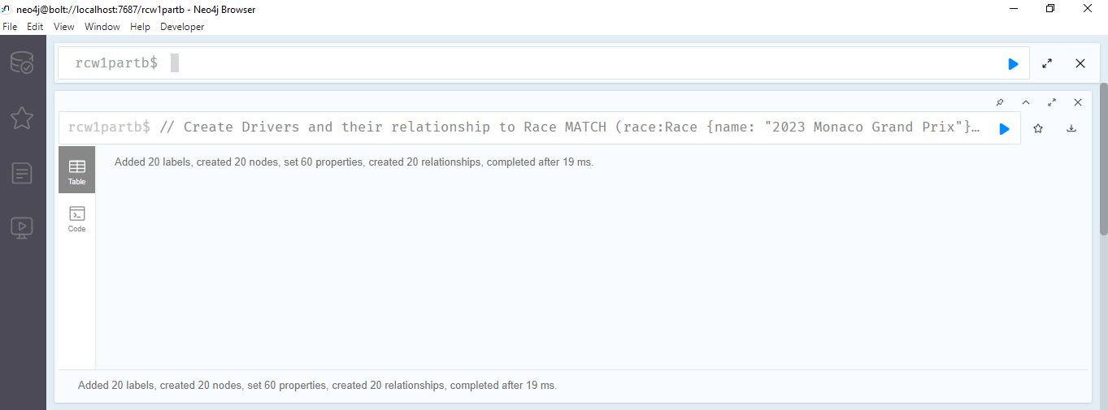

**B2. Queries**

We developed and executed Cypher queries to retrieve specific data from the database, as follows:

**Query 1: Retrieve all nodes and edges in the database**

MATCH (n)

RETURN n

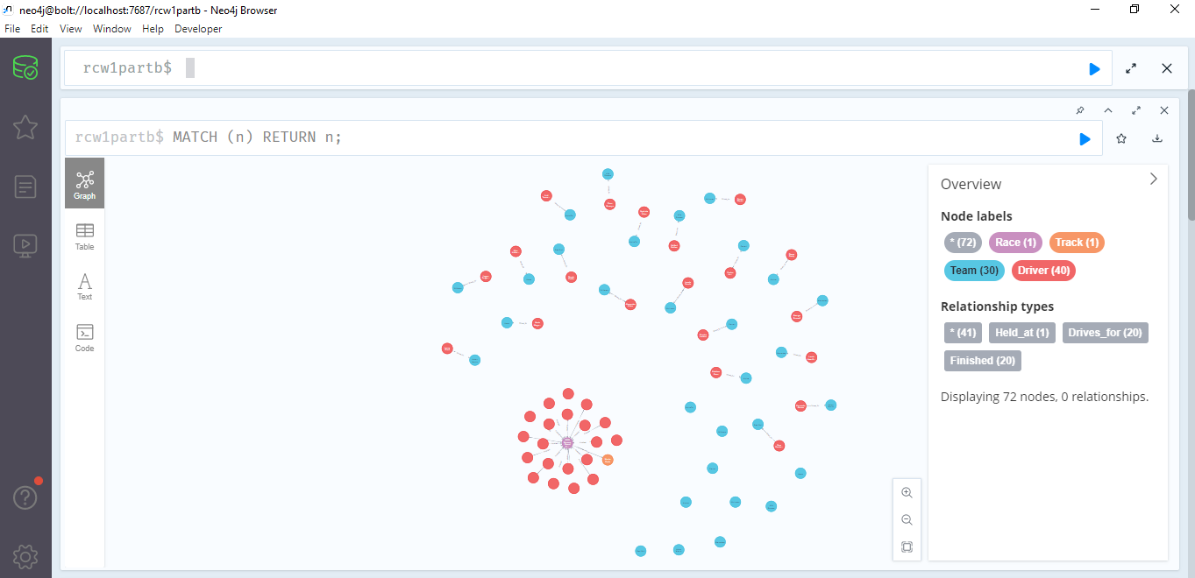

**Query 2: Retrieve drivers who drive for a specified team (e.g., "Red Bull")**

MATCH (team:Team {name: "Red Bull"})<-[:Drives_for]-(driver:Driver)

RETURN driver

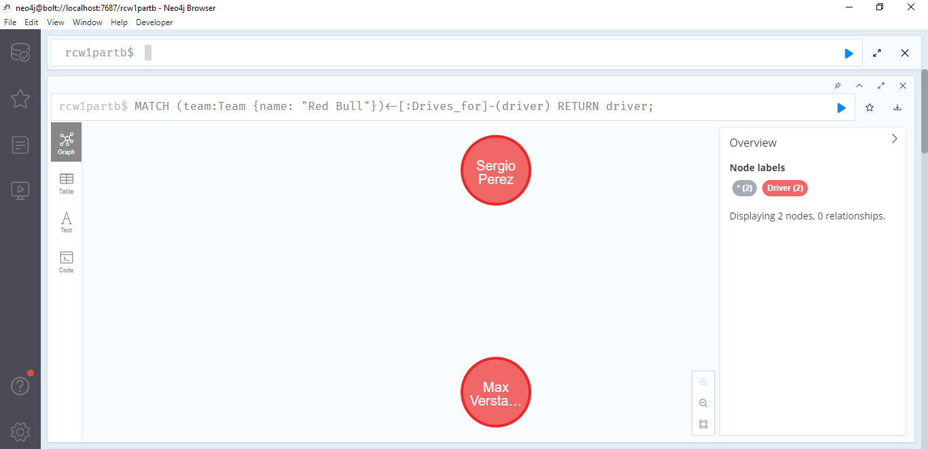

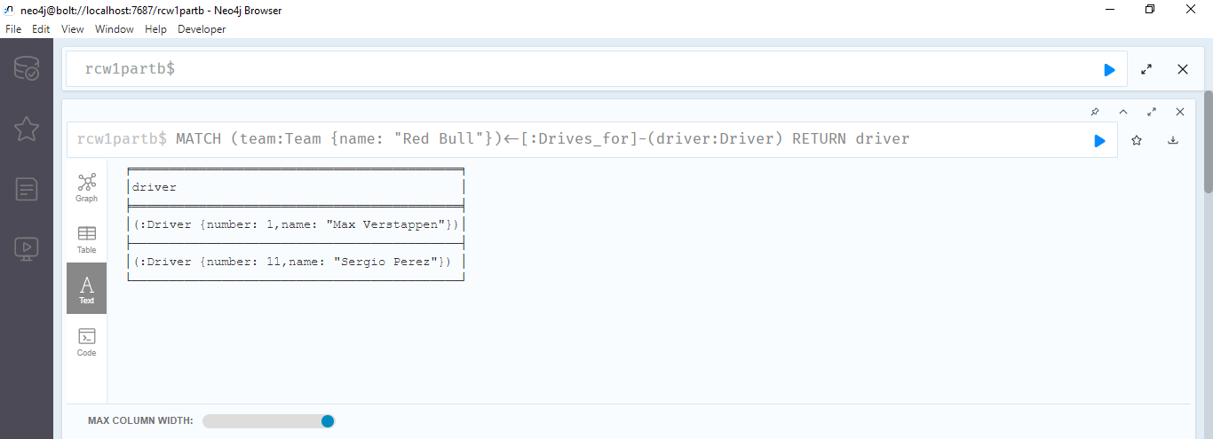

**Query 3: Retrieve the top ten finishers (drivers) in order**

MATCH (race:Race {name: "2023 Monaco Grand Prix"})<-[finished:Finished]-(driver:Driver)

WITH driver, finished

ORDER BY finished.position

LIMIT 10

RETURN driver

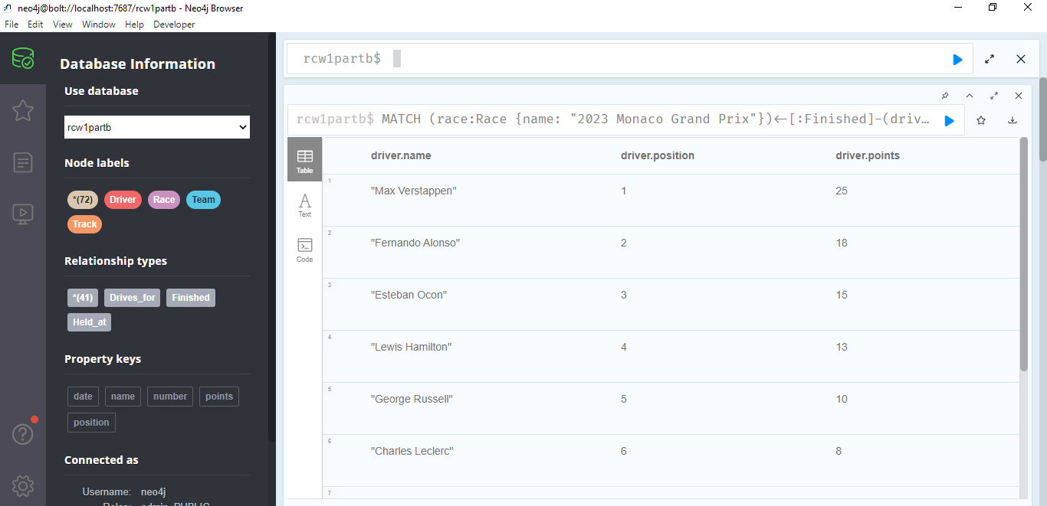

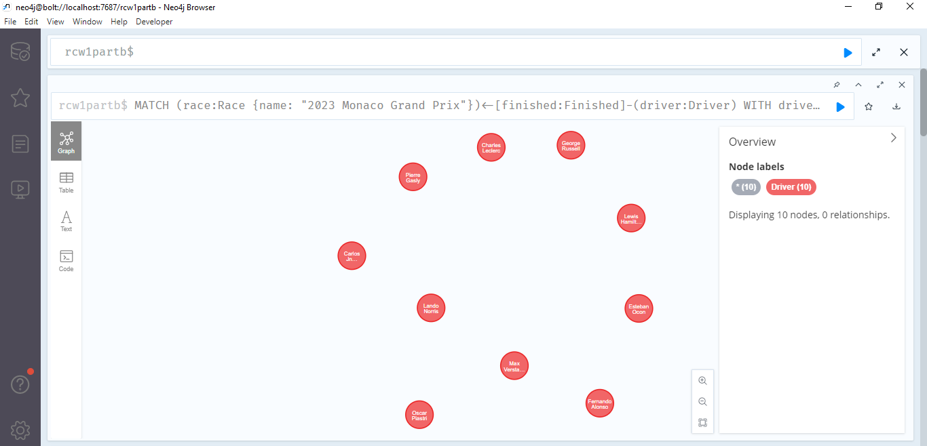

**Query 4: Retrieve the team-mate of a specified driver (e.g., "Max Verstappen")**

MATCH (driver:Driver {name: "Max Verstappen"})-[:Drives_for]->(team:Team)<-[:Drives_for]-(teammate:Driver)

WHERE teammate <> driver

RETURN teammate

**Query 5: Retrieve the number of points scored by a specified team (e.g., "Red Bull")**

MATCH (team:Team {name: "Red Bull"})<-[:Drives_for]-(driver:Driver)-[:Finished]->(race:Race {name: "2023 Monaco Grand Prix"})

RETURN SUM(CASE WHEN driver.position <= 10 THEN driver.points ELSE 0 END) AS teamPoints

**Conclusion:** In this report, we have outlined the process of creating and populating a Neo4j database based on the provided Formula 1 data model. We have also presented the Cypher queries devised and executed to retrieve specific information from the database. The database and queries accurately represent the Formula 1 data model, providing insights into races, teams, drivers, and race results.